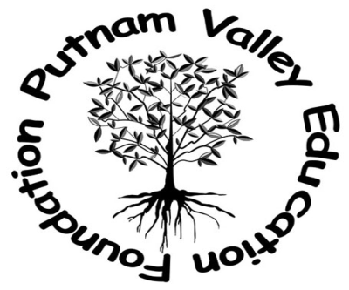

April 22, 2015

Dear Supporter:

The Putnam Valley Education Foundation is a not-for-profit organization which seeks to provide funding for educationally sound and innovative programs designed to enhance the educational experiences of the children in our district.
The Foundation works to accomplish these goals through the collective efforts of community members, parents, educators, students and alumni.
Our next fundraiser, Casino Night will be on Friday, June 5, 2015 at Putnam County Golf Course (187 Hill Street, Mahopac NY 10541). We are expecting many local area residents to attend this function and know that your generous donations will help make this event a big success.
We are asking businesses within and outside of our community to help support the PVEF’s event goals by either sponsoring a casino table for $100 and/or donating products or services. This is a great way to advertise your business and let the community know about your goods and services. All of the donors will be listed prominently during the event.

For your records, our Federal Tax ID number (EIN) is 11-37069219.

Thank you for your assistance.
Sincerely,
PVEF Volunteers

Ways to participate!
- Sponsor a table via our website pvefny.org by using PayPal
- Sponsor a table by check, payable to “PVEF” in the amount of $100.00 to P.O. Box 356, Putnam Valley, NY 10579.
- To arrange for a donation of goods or services, please contact us at pvefny@gmail.com.

