Our Mission
To aid the district in its pursuit of excellence in education by generating and distributing private funds that will provide opportunities for innovative programs and projects.

Our beginning
The Putnam Valley Education Foundation (PVEF) was established in 2003 by a group of community volunteers who hoped to augment the educational opportunities in the Putnam Valley Central School District.

Putnam Valley Education Foundation
Membership 2016-2017 School year

Name: _____________________________________________
Address: ___________________________________________
Telephone: __________________________________________
Email: ______________________________________________

Donations & Entitlements:
$10.00 - $25.00 _____ an acknowledgment on our web page under supporters
$50.00 _____ an acknowledgment on our web page under supporters and one free pass to our Annual Auction
$100.00 _____ an acknowledgment on our web page under supporters & two free passes to our Annual Auction
$ _____ Other (please note any donation that exceeds $150.00 entitles the donor to: an acknowledgment on our web page under supporters, two free passes to our Annual Auction, and acknowledgment in the Auction program

Membership form and donation may be mailed to:
Putnam Valley Education Foundation (PVEF)
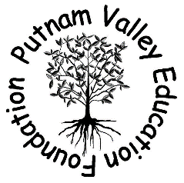
PO Box 356
Putnam Valley, NY 10579
Or
Deliver to: PVEF mailbox in the mail office of the ES, MS and HS
Or
Go to www.pvefny.org to become a member

