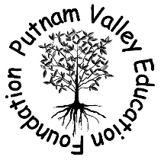
Our Mission
To aid the district in its pursuit of excellence in education by generating and distributing private funds that will provide opportunities for innovative programs and projects.

How we work?
Each year the funds raised by the PVEF are used for educationally sound programs and projects that cannot be funded by the district budget. Each spring, school administrators, teachers, and parents, or students with the support of their building administrator, are encouraged to submit grant applications. The Foundation’s Grant Committee reviews these applications and determines how best to allocate funds based upon each applications overall value to the district

Grants
Since 2004 we have granted $175,000 back to the Putnam Valley Schools

4th Grade Revolutionary War Re-Enactment
Animal Embassy
PVES STEAM Tech Equipment
Kindergarten Tool Kit
Bouncy Bands
PVES Summer Reading Challenge
1st Grade Mural Paint
PVHS Shakespeare Festival
Luncheons for 5th Grade and Incoming Freshman
PVES Yoga Mindfulness in School
PVHS Jacy Good Assembly

------------------------------------------------------------------------------------------------------------------------------------
Putnam Valley Education Foundation
Membership 2017-2018 School year

Name: _______________________________________________________
Address: _____________________________________________________
Telephone: ____________________________________________________
Email: _______________________________________________________

Donations & Entitlements:
_____ $10.00 an acknowledgment on our web page under supporters
$ _____ Other
- For every $50 you will receive 1 free ticket to our Auction on March 10th.
- 0th

Membership form and donation may be mailed to:
Putnam Valley Education Foundation (PVEF)
PO Box 356
Putnam Valley, NY 10579
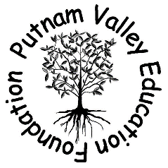
Or Deliver to: PVEF mailbox in the mail office of the ES, MS and HS
Or Go to www.pvefny.org to become a member

